Tutorial 7: Queue

- Four examples:
  - Cars lining up at a car wash.
  - Waiting for your turn at the doctor’s
  - Cup stack at the water dispenser (assume that it is refilled at the top and taken from the bottom)
  - Queue at the ticketing booth of a train station.
  - Phone calling system

Queue | Stack
First In First Out (FIFO) | Last In First Out (LIFO)
Elements are removed from the beginning of the queue | Elements are removed from the top of the stack
Common operations include enqueue and dequeue | Common operations include pop, push and peek

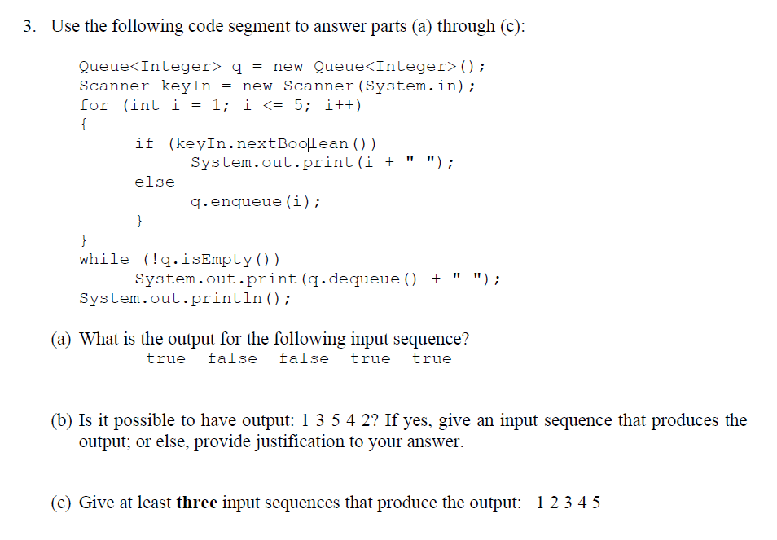

- 1 4 5 2 3
- No, this is due to the fact that 4 and 2 are in descending order. When the elements are queued into the queue, they will be queued in ascending order (1-5) and this will only allow 2 to be enqueued first followed by 4. Hence, the closest answer we can get is 1 3 5 2 4 (true false true false true).

  - false false false false false
  - true true true true true
  - true true true true false

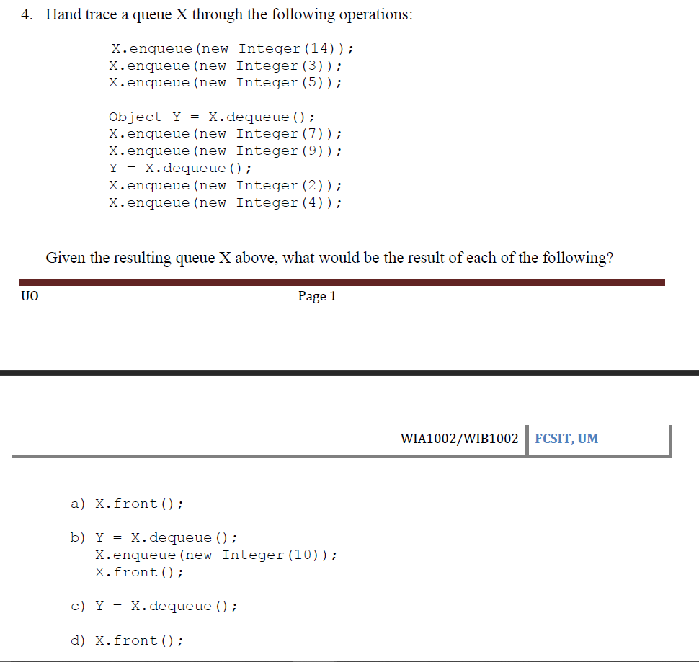

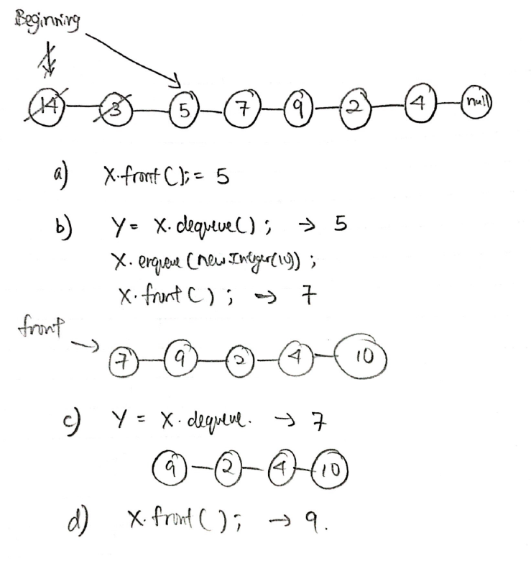

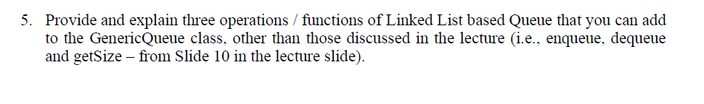

- Public boolean contains(E e)
Checks to see if the queue contains a certain entry. Returns true if the queue contains the entry, false otherwise.
- Public E peek();
Returns the first element of the queue.
- Public boolean remove(E e);
Removes a specific element from the queue. If there are more than two identical elements, remove the first occurring one. If remove successful, returns true, false otherwise.

Tutorial 7b: Priority queue

In a queue, the first-in-first-out rule is implemented whereas, in a priority queue, the values are removed on the basis of priority. The element with the highest priority is removed first.

- ExpressPass used in Theme parks.
- Filtering section when you are selecting a restaurant from google maps or some other applications (ranks based on what you want – reviews, cost, etc)
- Teachers selecting students to participate in a prestigious event based on merits.

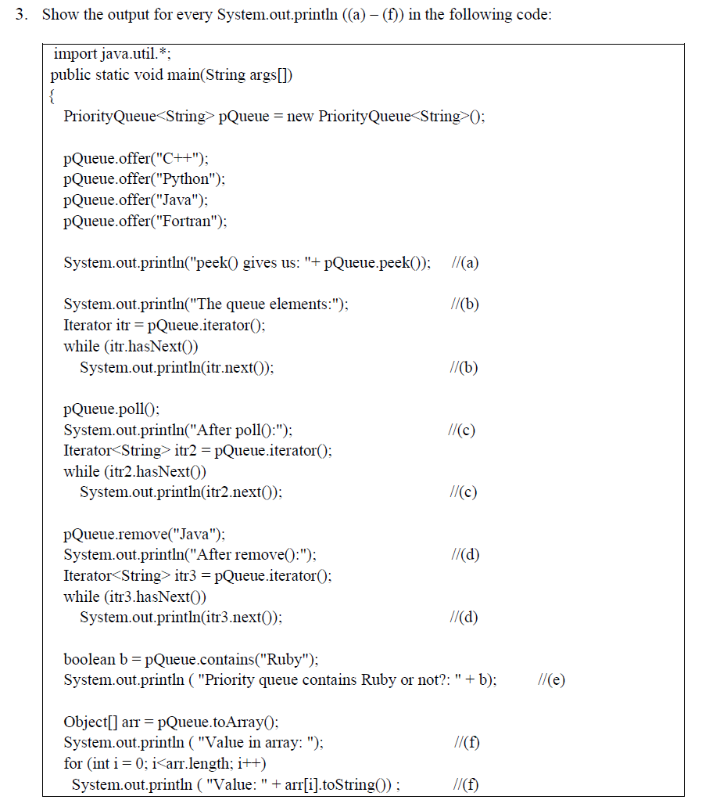
- peek() gives us: C++

The queue elements:
C++
Fortran
Java
Python

After poll():
Fortran
Python
Java

After remove():
Fortran
Python

- Priority queue contains Ruby or not?: false

Value in array:
Value: Fortran
Value: Python

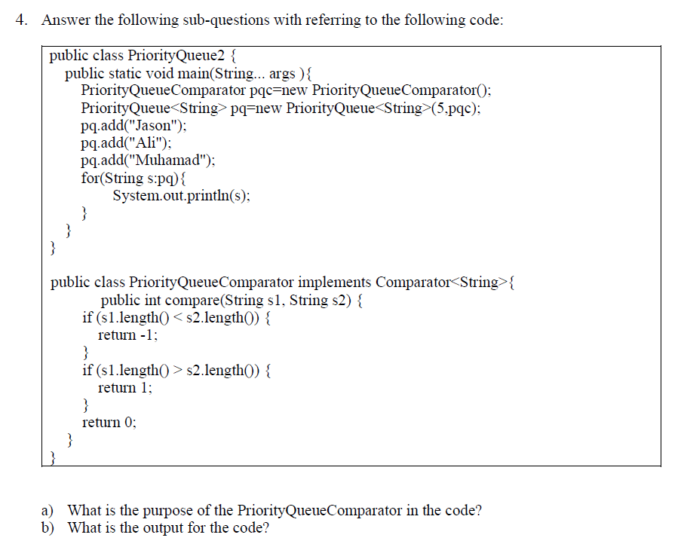

- Purpose of the PQC is to have control over how we rank our elements in the priority queue, in this case the shortest string has the highest priority over longer ones.

Ali
Jason
Muhamad

